***Main source used for taking this note: Essential Biochemistry - Charlotte Pratt & Kathleen Cornely***

**\*Mitochondrial ETC Complexes:**

* **Complex I**: NADH dehydrogenase or NADH:ubiquinone oxidoreductase - initiating ETC by oxidizing NADH, transferring electrons to ubiquinone.
* **Complex II:** succinate dehydrogenase.
* **Complex III:** ubiquinol:cytochrome c oxidoreductase – transferring electrons from ubiquinol to cytochrome c.
* **Complex IV:** cytochrome c oxidase - final electron transfer to oxygen, forming water.
* A structure of a chemical formula

  Description automatically generated**Complex V**: ATP synthase/F1F0-ATPase.

**\*Citric acid** is an organic compound with the chemical formula HO-C(CH₂CO₂H)₂. It occurs naturally in citrus fruits. In biochemistry, it is an intermediate in the citric acid cycle, which occurs in the metabolism of all aerobic organisms.

**Input to TCA cycle:** carbon atoms derived from amino acids, fatty acids, or carbohydrates. 8 reactions are involved.

**PYRUVATE DEHYDROGENASE REACTION (RIGHT BEFORE TCA CYCLE)**

The pyruvate dehydrogenase complex (~4600kDa) includes three types of enzymes (E1, E2, E3, containing 60 protein subunits) that collectively remove a carboxylate group from pyruvate (3-carbon) and produce acetyl-CoA and NADH. (Transferring acetyl unit to coenzyme A)



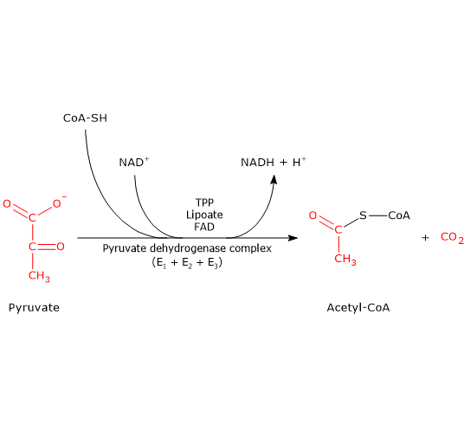

**Location**: Mitochondrial matrix

**Substrate**: Pyruvate (3-carbon compound)

**Steps**:

* Decarboxylation: Removal of a carboxyl group from pyruvate with the help of thiamine pyrophosphate (TPP), a vitamin B1 derivative.
* Oxidation: The remaining two-carbon fragment is oxidized, transferring the energy to a swinging arm called lipoamide.
* Trans-acetylation: The acetyl group is transferred from lipoamide to CoA, forming acetyl-CoA.
* Reduction: Electrons from the oxidation are used to reduce NAD+ to NADH, which fuels the electron transport chain and ATP production.

**Product**: Acetyl-CoA

**Significance**: Connects glycolysis and citric acid cycle in cellular respiration.

**Result**: Acetyl-CoA enters the citric acid cycle for further energy extraction.

**THE EIGHT REACTIONS OF TCA CYCLE**

With the entry of **1 acetyl group** into the citric acid cycle,

* **2 fully oxidized CO2 molecules** are generated, indicating the loss of **4 pairs of electrons**.
* These electrons are then conveyed to **3 NAD+ molecules** and **1 ubiquinone (Q),**
* Resulting in the production of **3 NADH and 1 QH2**.

Consequently, the summarized equation for the citric acid cycle is as follows:



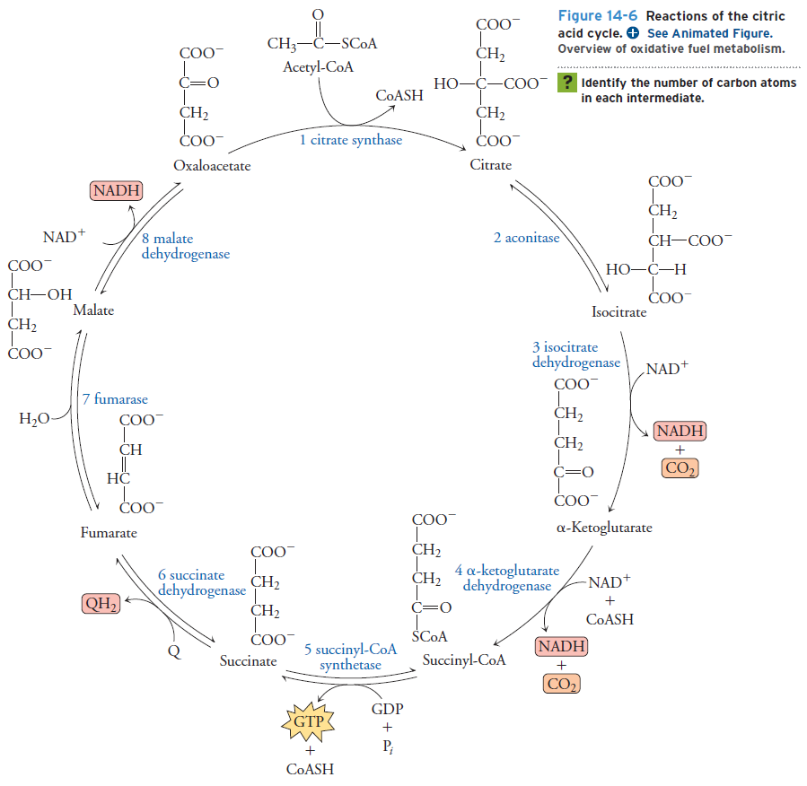

**1. Citrate Synthase** (Derived from its catalytic activity in forming citrate):

* Location: Mitochondrial matrix
* Reaction: **Acetyl-CoA** (CH₃COSCoA) + **Oxaloacetate** (HO₂CCCH₂CO₂H) → **Citrate** (HO₂CCH₂CH(OH)CO₂H) + CoA (HSCoA)

* Is the entry point for acetyl-CoA. Condenses a two-carbon acetyl group with a four-carbon oxaloacetate to form a six-carbon citrate.

**2. Aconitase** (Named after aconitic acid, an intermediate product):

* Location: Mitochondrial matrix
* Reaction: Citrate (HO₂CCH₂CH(OH)CO₂H) → cis-Aconitate (HO₂CCH=CHCO₂H) → iso-Citrate (HO₂CCH(OH)CH₂CO₂H)

* Isomerizes citrate into two stereoisomers (cis-aconitate and iso-citrate) using iron-sulfur clusters. Regulates the cycle's rate by controlling citrate availability.

**3. Isocitrate Dehydrogenase** (removing hydrogen from iso-citrate):

* Location: Mitochondrial matrix
* Reaction: **iso-Citrate** (HO₂CCH(OH)CH₂CO₂H) + **NAD+** → **α-Ketoglutarate** (HO₂CCH₂COCO₂H) + CO₂ + **NADH**
* First decarboxylation step, generating a five-carbon α-ketoglutarate, releasing CO₂, and producing NADH, a high-energy electron carrier.

**4. α-Ketoglutarate Dehydrogenase**:

* Location: Mitochondrial matrix, **bound to inner membrane (part of ETC complex I)**
* Reaction: **α-Ketoglutarate** (HO₂CCH₂COCO₂H) + CoA (HSCoA) + **NAD+** + **FAD+** → **Succinyl-CoA** (CH₂CO-SCoA) + CO₂ + **NADH** + **FADH₂**

* Second decarboxylation and major ATP production step. Occurs within the ETC complex I, transferring electrons to NADH and FADH₂ for ATP generation via oxidative phosphorylation.
* The free energy of oxidizing α-ketoglutarate is conserved in the formation of the **thioester succinyl-CoA**.

**5. Succinyl-CoA Synthetase** (Combines substrate-level phosphorylation with CoA transfer):

* Reaction is reversible. The enzyme is named for the **reverse** reaction.
* Location: Mitochondrial matrix
* Reaction: **Succinyl-CoA** (CH₂CO-SCoA) + GDP/ADP + Pi → **Succinate** (HOOCCH₂CH₂CO₂H) + GTP/ATP + CoA (HSCoA)
* **Substrate-level phosphorylation,** **directly** generating one ATP through the **transfer of a phosphate group** to GDP/ADP (to distinguish it from oxidative phosphorylation and photophosphorylation).

**6. Succinate Dehydrogenase** (SDH – complex II, **other 7/8** TCA enzymes are soluble in matrix):

* Location: Mitochondrial inner membrane **(part of ETC complex II)**
* Reaction: Succinate (HOOCCH₂CH₂CO₂H) + **FAD+** → **Fumarate** (HOOCCH=CHCO₂H) + **FADH₂**
* Reversible between succinate and fumarate; require an FAD prosthetic group, which is reduced to FADH2.

(To regenerate the enzyme,) the FADH2 group is reoxidized by the lipid-soluble electron carrier ubiquinone (Q). (Uniquinol: QH2)

**7. Fumarase (also fumarate hydratase) catalyzes a hydration reaction**

* Location: Mitochondrial matrix
* Reaction: **Fumarate** (HOOCCH=CHCO₂H) → **L-Malate** (HOOCCH₂CH(OH)CO₂H)
* Hydrates fumarate (hydration of a double bond) to form malate, an isomerization step without energy input or output. Connects the TCA cycle to gluconeogenesis and other metabolic pathways.

**8. Malate Dehydrogenase (Removes hydrogen from malate and regenerates oxaloacetate):**

* Location: Mitochondrial matrix
* Reaction: L-Malate (HOOCCH₂CH(OH)CO₂H) + NAD+ → Oxaloacetate (HO₂CCCH₂CO₂H) + CO₂ + NADH
* NAD+ dependent oxidation reaction

**Summary/Other points:**

* The entire TCA pathway acts in a catalytic fashion to dispose of carbon atoms derived from amino acids, carbohydrates, and fatty acids.
* Muscle Energy Production:
  + Anaerobic operation: Produces only **2 ATP per glucose.**
  + Aerobic conditions: Fully active citric acid cycle leads to **approximately 32 ATP equivalents** from a single glucose molecule.

Regulation of Citric Acid Cycle: Regulated at three metabolically irreversible steps:

* Citrate synthase (Reaction 1).
* Isocitrate dehydrogenase (Reaction 3).
* 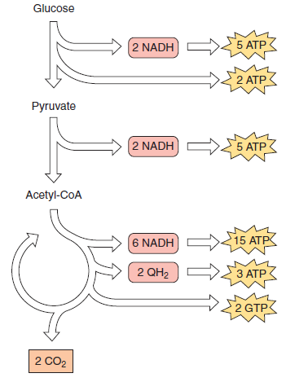**A diagram of a cycle

  Description automatically generated**Alpha-ketoglutarate dehydrogenase (Reaction 4).

**Regulation of TCA cycle.**

Red: inhibition, Green: Activation

**Pyruvate Entry:**

* Pyruvate, the **end product of glycolysis**, undergoes an oxidative decarboxylation by the **pyruvate dehydrogenase complex.**
* This reaction yields **acetyl-CoA,** a two-carbon fuel for the citric acid cycle, along with **carbon dioxide** and **NADH**, an electron carrier molecule.

**Citric Acid Cycle:**

* The citric acid cycle, a **multistep enzymatic pathway**, functions as a central metabolic hub.
* It **condenses acetyl-CoA with oxaloacetate** to form citrate, initiating a series of oxidative transformations.
* These transformations extract the acetyl-CoA's two carbons, releasing them as two molecules of carbon dioxide.
* Simultaneously, electrons and protons are captured by **NAD+ and FAD**+, generating **NADH and FADH2**, high-energy electron carriers.

**Electron Transfer and ATP Production:**

* Electrons and protons from NADH and FADH2 enter the **electron transport chain**, fueling oxidative phosphorylation.
* This process couples electron transfer with ATP synthesis, generating the majority of cellular ATP.

**Beyond Energy Generation:**

* The citric acid cycle is not solely an energy-generating pathway.
* Intermediates serve as vital precursors for a diverse array of biomolecules, including amino acids, nucleotides, and heme groups.

**Catalytic Regulation:**

* The citric acid cycle operates as a **catalytic system**, with its rate dependent on the concentration of its components.
* Increased levels of intermediates and cofactors enhance the cycle's flux, amplifying its metabolic output.

**Exercise and Cycle Activity:**

* During exercise, skeletal muscle exhibits a **dramatic upregulation of the citric acid cycle**.
* Intermediates can increase 3-4 fold, while cycle flux can surge up to 100-fold due to elevated activities of key enzymes.
* This enhanced activity likely accommodates the increased pyruvate production associated with elevated glycolytic rates during exercise.

